

SOFTWARE DESIGN SPECIFICATION
Project Name (Code)

– Hanoi, Sep 2025 –

Table of Contents
I. Record of Changes 3
II. Software Design Document 4
1. High Level Design 4
1.1 Software Architecture 4
1.2 Package Diagram 4
1.3 Database Design 5

I. Record of Changes
Date | A*  M, D | In charge | Change Description
*A - Added M - Modified D - Deleted

II. Software Design Document

1. High Level Design

1.1 Software Architecture
[The content of this section includes the overall architectural diagram which includes the sub-systems and/or components, the external systems (if any), and the relationships (communication messages) among them. You need also provide the explanation for each of the diagram components (modules, sub-systems, external systems, etc.)].
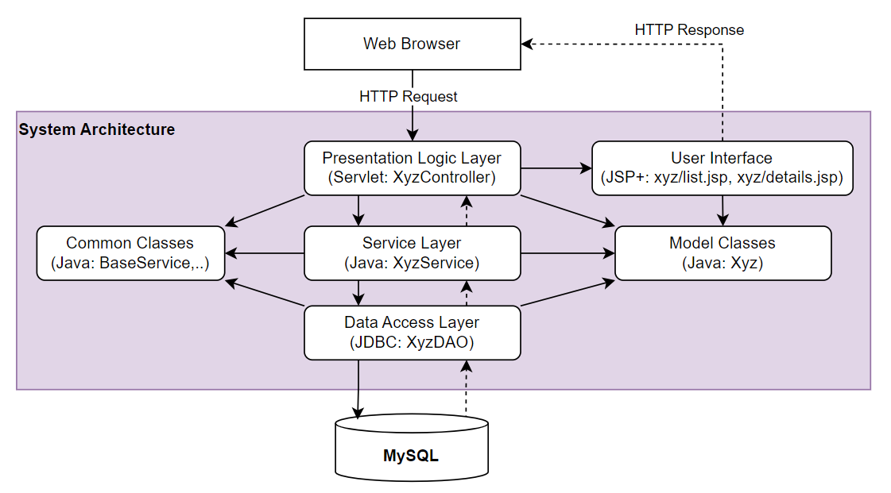-

1.2 Package Diagram
No | Package | Description
01 | Member_authority | <Description of the package>
02 | registration | <Description of the package>
03 | …

This section outlines the logical package structure of the vLance Freelance Marketplace (LancerPro / CNY) system. The architecture is strictly separated into the Backend (Spring Boot 3.x) and Frontend (React 18), utilizing a modular and layered approach to ensure separation of concerns, maintainability, and scalability.

1.2.1 Overall Package Diagram

The following Mermaid diagram illustrates the package dependencies for both the Backend API and the Frontend Single Page Application (SPA).

package "vLance Application" {
package "Frontend (React SPA) - src/" {
[pages] --> [features]
[features] --> [components]
[features] --> [api]
[features] --> [context]
[api] --> [utils]
[components] --> [assets]
}
package "Backend (Spring Boot) - com.cny.backend" {
[controller] --> [service]
[controller] --> [dto]
[service] --> [repository]
[service] --> [entity]
[repository] --> [entity]
[config] --> [security]
[security] --> [service]
[exception] -.-> [controller] : handles
}
[api] ..> [controller] : HTTPS / REST (JSON)
[pages] ..> [controller] : WebSocket (STOMP)
}

1.2.2 Package Descriptions (Backend)

The Backend adheres to a strict Layered Architecture. Business logic is strictly confined to the service layer.

Package Name | Description | Classes / Content
com.cny.backend.config | Configuration classes for the Spring context, including Web, CORS, WebSocket, and external integrations (VNPay, PayOS). | SecurityConfig.java, WebSocketConfig.java, VNPayConfig.java
com.cny.backend.security | Security layer implementation including JWT generation/validation, authentication filters, and custom user details. | JwtAuthFilter.java, JwtUtils.java, CustomUserDetailsService.java
com.cny.backend.controller | Presentation layer exposing RESTful API endpoints. Responsible for receiving requests and delegating to services. | AuthController.java, ProjectController.java, PaymentController.java
com.cny.backend.service | Business logic layer containing interface definitions and their implementations. Manages transactions. | UserService.java, UserServiceImpl.java, EscrowService.java
com.cny.backend.repository | Data access layer using Spring Data JPA. Interfaces extending JpaRepository for database interactions. | UserRepository.java, ProjectRepository.java
com.cny.backend.entity | JPA Domain models mapping directly to SQL Server tables (@Entity, @Table). | User.java, Project.java, ServicePackageConfig.java
com.cny.backend.dto | Data Transfer Objects used to encapsulate data sent between the client and server, preventing entity exposure. | LoginRequest.java, ProjectResponse.java, UserProfileDto.java
com.cny.backend.exception | Global exception handling using @ControllerAdvice. Centralizes error formatting into standardized payloads. | GlobalExceptionHandler.java, ResourceNotFoundException.java

1.2.3 Package Descriptions (Frontend)

The Frontend utilizes a feature-sliced design (FSD) approach combined with traditional layered components to keep the React codebase modular.

Package Name | Description | Files / Content
src/pages | Top-level route components mapped via React Router. Aggregates features and layouts. | HomePage.jsx, AdminDashboardPage.jsx, CheckoutPage.jsx
src/features | Encapsulated feature modules containing domain-specific logic, API hooks, and UI components. | auth/, admin/, freelancer/, employer/
src/components | Reusable, stateless UI components (Design System) independent of business logic. | Button.jsx, Modal.jsx, Navbar.jsx, Footer.jsx
src/api | Centralized Axios instances, interceptors, and API route definitions for backend communication. | apiClient.js, adminApi.js, authApi.js
src/context | Global state management using React Context API for themes, auth states, and socket connections. | AuthContext.jsx, SocketContext.jsx
src/hooks | Custom React Hooks for encapsulating complex state or lifecycle logic. | useAuth.js, useFetch.js, useDebounce.js
src/utils | Pure helper functions for formatting, validation (Zod schemas), and calculations. | formatCurrency.js, validationSchema.js
src/assets | Static files such as images, icons, and global CSS stylesheets. | images/, index.css, tailwind.css

1.2.4 Naming Conventions

Strict adherence to naming conventions ensures consistency across the workspace.

Target Component | Convention | Example
Java Classes / Interfaces | PascalCase | UserServiceImpl.java, FreelancerController.java
Java Methods / Variables | camelCase | findByEmail(), jwtToken, verifyPayment()
Java Packages | lowercase | com.cny.backend.security
React Components (JSX) | PascalCase | UserProfile.jsx, PaymentModal.jsx
React Hooks | camelCase (Prefix: use) | useAuth(), useWebSocket()
JS/JS Files (Non-JSX) | camelCase | apiClient.js, formatUtils.js
Database Tables / Columns | snake_case (lowercase) | freelancers, service_package_configs, created_at
CSS Classes (Tailwind/Vanilla) | kebab-case | btn-primary, nav-item, text-blue-500

1.3 Database Design
[Provide the files description, database table relationship & table descriptions like example below]

1.3.1 table_name1
[Provide brief description of the table here]
[Provide the detailed table fields description using below table format
* PK~Primary Key; FK~Foreign Key; UN~Unique; NN ~ not null
No | Field | PK | FK | UN | NN | Description
01 | <field_name1> |  |  |  |  | <Description of the field_name1>
02 | <field_name2> |  |  |  |  | …
..

1.3.2 table_name2
…

